How to check update file and game client installation integrity?

Contents
- Introduction
- Program installation
- Downloaded file checksum verification

Introduction
If you experience problems during unzipping or installation of the game client with help of the installer or the update file, it is recommended to check the integrity of the downloaded files. It is possible that files could be damaged during the downloading.
HashTab software can be used to check the integrity of the downloaded update.
HashTab – Windows explorer extension for checking integrity and files authenticity by calculating the checksum. HashTab supports a number of hash algorithms such as CRC, MD5, SHA1, SHA2, SHA3/Keccak, RipeMD and Whirlpool, as well as BitTorrent Info Hash and Magnet-links generation.

Program Installation
Windows XP or higher, including Windows Vista, Windows 7, Windows 8 x32 or x64 are required to run HashTab. The program can be freely distributed for personal use.
- Download the program from there.
- Launch HashTab v5.1.0.23 Setup.exe file and carefully follow the installation instruction:
- Press Next >.
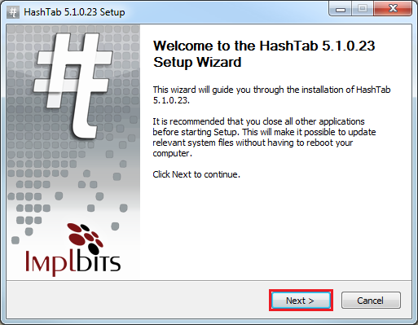
- Get acquainted with HashTab license agreement. Carefully read the agreement and if you agree with its paragraphs, please press the button I Agree. Program installation on the computer will continue.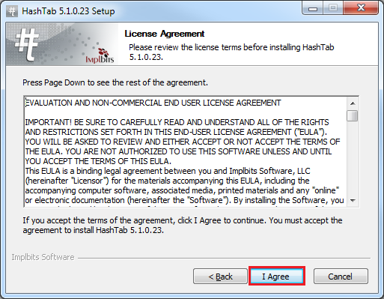
- Specify the path where the program should be installed with help of the button Browse…, and then press Install. 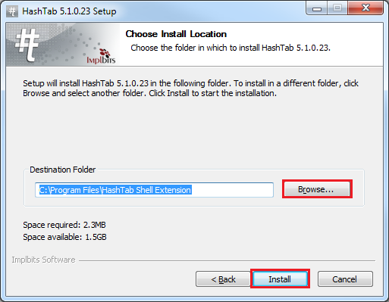
- Wait until installation is complete and press Finish.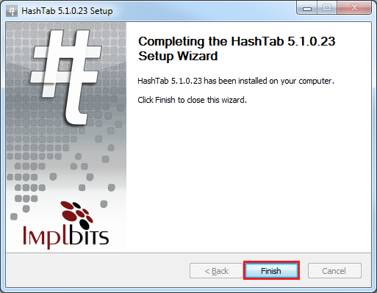

Downloaded checksum file verification
Let us carry out checksum file verification on the example of the update file.
- Please right-click on the downloaded file, select “Properties” in the shortcut menu.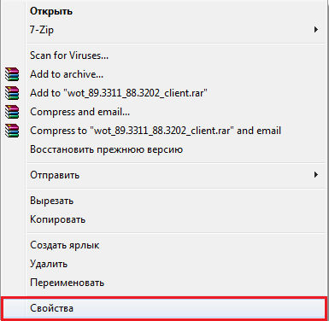

- Go to the section “Files hash sum” in the window, which appeared. Program will automatically begin checking. 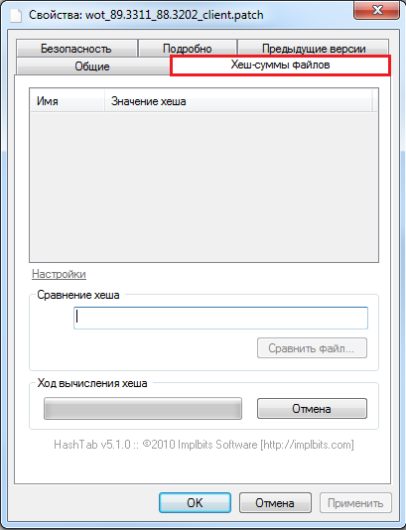
- Copy MD5-sum on the portal in section “Download game”. 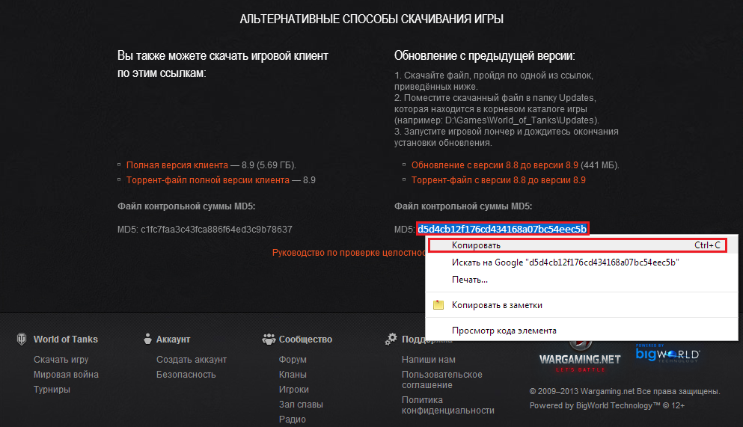
- Go back to the window “Properties” > “Files hash-sum” and paste the copied sum to the field “Hash comparison”. The program will report about matches and mismatches of the checksum. 